**CHAPTER III**

**METHODS**

This chapter will discuss the various aspects of the devised methodology that will be strictly followed. Specifically, it will discuss the research design, materials and methods, measures, application testing and simulation, system flow, and system design.

**Research Design**

This research project will employ an applied research design. According to Hedrick et al., (1993), unlike basic research where it is theoretical in nature, applied research design is practical and descriptively employed to allow the researcher to build knowledge and develop practical solutions for a certain research problem. In other words, the objective of applied research is to develop a product to solve a looming issue that a society is currently dealing. In this case, applied research design is a suitable research design to employ since the research project is aiming to provide a solution for the identified lack of inclusive catalog and tracking of the COVID-19 situation in the locality.

Additionally, for the development protocol, the researcher will employ a Software Development Life Cycle (SDLC) model called Agile. For the development of softwares, it is highly necessary to adopt SDLC models for it provides a compelling foundation as well as a clearly defined strategy for the development of the software applications. The most basic SDLC model adopted is Waterfall for software and web development (Chandra, 2015; Kumar Pal, 2018). However, adopting the classical waterfall model in a real-world web application development project is impractical since it is idealistic and challenging to implement (Kumar Pal, 2018). Moreover, the sequential nature of the Waterfall SDLC made it unsuitable for this project. That is why the project development methodology will adopt another SDLC model called Agile Model. The said framework is different from the expected linear sequential life cycle of the Waterfall Model.

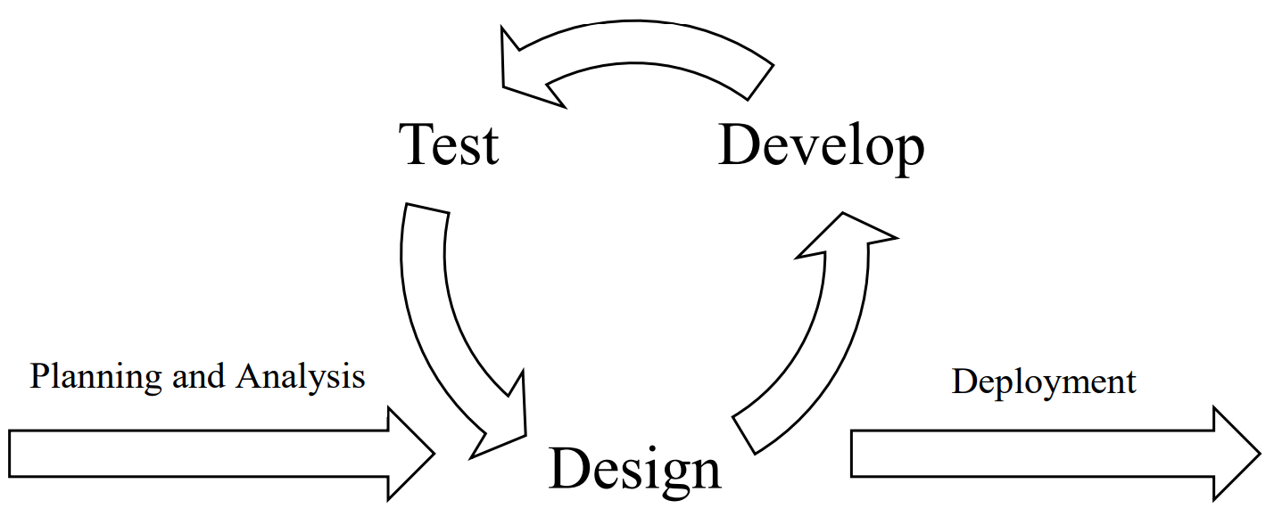

***Figure 2.*** Agile Software Development Life Cycle Model

The primary purpose of the Agile Software Development model is to facilitate quick project completion adaptively. The salient nature of Agile SLDC will allow the researcher to adapt to the unexpected circumstances in the development process due to its iterative and incremental nature (Figure 1). In other words, the researcher can make it up as the project goes along with the Agile Model. Whereas the Waterfall SLDC model, the researcher will structure everything before starting the project. However, with no adaptability due to its linear sequential flow, any erroneous prospects and consequences will be disregarded and not be rectified (Chandra, 2015). That is why the researcher will adopt the Agile Model since it is the most suitable SLDC model that allows the researcher to employ the advantages such as adaptability, efficiency, flexibility, incremental and continuous iteration, the high success rate with less time requirement, risk-reduction, and the elimination of cost (Dixit et al., 2020). Thus, the research project design will also adopt the Agile Model software development cycle.

**Materials and Methods**

**Pre-development Phase**

**Materials**

**Designing the Web Application**

**System Flow**

**System Design**

**Web Application Testing and Simulation**